**REPLASTIX INNOVATIONS: TRANSFORMING PLASTIC WASTE INTO SUSTAINABLE SOLUTIONS**

**Abstract**

This project, titled "Replastix innovations: transforming plastic waste into sustainable solutions", was undertaken as part of the summer internship at SmartBridge. The project aimed to build a customized Salesforce application that supports the operational processes of RePlastix Innovations, a company working toward sustainable plastic waste management.

The primary goal was to replace manual, time-consuming workflows with an automated, centralized CRM solution using Salesforce. To achieve this, custom objects were designed for Plastic Waste, Recycling Centers, Recycled Products, Orders, and Restock Requests. Automation was introduced using Flow Builder to schedule daily inventory checks, and Apex triggers were written to handle real-time stock adjustments and replenishment processes.

Role-based access controls were enforced using organizational-wide defaults, roles, and sharing rules. Validation rules ensured data consistency, while email notifications enhanced communication between departments such as inventory and warehouse management.

Through hands-on development, testing, and deployment, the project delivered a scalable Salesforce-based platform that increased process transparency, reduced delays in restocking, and provided real-time reporting dashboards for key metrics. This internship enabled me to apply academic knowledge in a real-world business environment and strengthened my technical expertise in Salesforce development.

**Project Overview**

The plastic waste management sector has grown significantly over the past decade due to increasing environmental awareness and government regulations. In India, plastic waste generation has become a major environmental concern, with millions of tons of plastic ending up in landfills, oceans, and urban areas every year. This has not only caused ecological harm but has also posed serious health risks.

To address these challenges, the Indian government has launched several initiatives such as the Plastic Waste Management Rules (2016) and Swachh Bharat Abhiyan. These policies emphasize the importance of recycling, segregation at source, and Extended Producer Responsibility (EPR), which encourages manufacturers to manage plastic waste throughout its lifecycle.

In this context, the role of technology becomes crucial. Many companies are integrating cloud-based platforms like Salesforce to build transparent, traceable, and data-driven waste management systems. CRM systems enable stakeholders to track plastic waste from collection to recycling and further to finished products. Automation tools, data analytics, and real-time dashboards further support quick decision-making, efficient stock control, and improved customer satisfaction.

The plastic waste management industry is thus evolving into a sustainability-driven, tech-enabled ecosystem, where smart solutions not only protect the environment but also create new opportunities for innovation and green entrepreneurship.

**Objectives**

The project aimed to develop a CRM application that would streamline waste processing while providing automation, scalability, and usability. Major goals include:

* Automating repetitive manual processes like inventory monitoring and restocking
* Ensuring accurate, real-time data using validation and formula fields
* Enhancing decision-making with dashboards and analytics
* Implementing robust data security through roles, profiles, and sharing settings
* Empowering warehouse, sales, and collection teams with specific tools tailored to their roles
* Supporting future sustainability and circular economy efforts

**Phase 1: Requirement Analysis & Planning**

Understanding Business Requirements

**Key requirements identified:**

* Track and manage different types of plastic waste
* Log recycling center capacity to avoid overloads
* Monitor recycled product inventory levels
* Automatically create restock requests for low stock
* Handle customer orders and notify teams for pending stock

**Project Scope**

* 5 custom objects with relevant fields
* Validation rules to prevent incorrect inputs
* Automation for stock checks, restocking, and task assignment
* Secure access with record-level visibility

**Data & Security Design**

* Entity Relationship Diagram (ERD) drafted
* Profiles and Roles defined (CEO, Sales Rep, Warehouse Supervisor)
* Organizational Wide Defaults (OWD) set to Private
* Sharing rules configured to maintain access control

**Phase 2: Salesforce Development – Backend & Configurations**

**Environment Setup**

* Developer Org created for development
* Lightning App Re Plastic Innovations configured
* Navigation tabs added for each object

**Object and Field Setup**

1. **Custom objects:**

* Plastic_Waste__c: Weight, Type, Date, Location
* Recycling_Center__c: Location, Capacity
* Recycled_Product__c: Stock Level, Threshold, Price
* Order__c: Product, Quantity, Customer, Delivery Date
* Restock_Request__c: Product, Requested Quantity, Status

1. **Validation Rules**

* No future dates for waste collection
* Quantity > 0 for orders

**Apex Classes & Triggers**

* InventoryManager: Handles stock reduction and restock logic
* EmailNotificationHelper: Sends email after restock approval
* Triggers to run logic on insert/update of Order and Restock Request objects

**Flows**

**Scheduled Flow runs daily at 6 AM to:**

* Check product stock levels
* Create tasks when stock is low

**Phase 3: UI/UX Development & Customization**

* The app's interface was designed for ease of use:
* Lightning App with navigation items for all key objects
* Page Layouts for relevant fields organized by section
* Dynamic Forms used to show fields conditionally
* Reports & Dashboards created:
* Stock levels
* Pending restock requests
* Completed orders
* Profiles and roles customized to display user-specific data

**Phase 4: Data Migration, Testing & Security**

**Data Setup**

* Sample data imported using Data Import Wizard
* Manual records created for automation and trigger testing

**Security**

* OWD: Private
* Sharing Rules:
* CEO ➝ Sales Rep (Recycled Products)
* Sales Rep ➝ Warehouse Supervisor (Restock Requests)
* CEO ➝ Recycling Manager (Plastic Waste)

**Testing**

* Test cases covered:
* Trigger activation on order insert
* Stock reduction
* Restock request generation
* Status change to Approved → stock increase
* Email delivery
* Apex Test Class InventoryManagerTest:
* Setup test data
* Simulated stock operations
* Validated 100% code coverage

**Phase 5: Deployment, Documentation & Maintenance**

**Deployment**

* Used Change Sets for structured deployment
* Tested Flows, Triggers, and Apex classes before migration

**Documentation**

* Detailed notes on object logic, validation rules, and user roles
* Diagrams and screenshots prepared (placeholders)

**Maintenance**

* Debug logs used to track automation execution
* Field history tracking enabled for key fields
* Monitoring flows and scheduled jobs recommended post-deployment

**CONCLUSION**

Through this internship project, I was able to build a fully functional Salesforce-based solution that helped RePlastix Innovations manage their plastic recycling and inventory operations more efficiently. The project began with creating custom objects to record different aspects of the business such as plastic waste collection, recycling centers, recycled products, customer orders, and restock requests. Each object was carefully designed with relevant fields and relationships to ensure the data was well-structured and easy to manage.

As the system requirements included automation, I implemented scheduled flows using Salesforce Flow Builder. These flows checked stock levels every morning at 6:00 AM and automatically created a task if any product’s stock fell below the threshold. This reduced manual monitoring and helped the organization take timely restocking action. I also wrote Apex classes and triggers to handle more complex logic. When a new order was placed, the stock was automatically reduced, and if the stock was insufficient, a restock request was generated. Once the restock request was approved, the stock level was increased again without manual input.

To keep users informed, I used Apex to send an automated email to the warehouse manager whenever stock was updated. This improved communication and helped coordinate between departments. I also worked on data security using Salesforce’s role hierarchy, profiles, and sharing settings. Only authorized users like the CEO, Recycling Manager, Sales Representative, and Warehouse Supervisor were given access to their relevant data using role-based access control. I added validation rules to make sure that incorrect data, like a future date for plastic collection or zero quantity for an order, could not be entered.

All automation and logic were tested using test classes. The code passed all tests with over 90% coverage, showing the system was reliable and ready for deployment. From this project, I learned how to apply classroom concepts to real-world challenges. I gained hands-on experience in Salesforce development including object modeling, flows, Apex programming, security setup, testing, and system deployment. Most importantly, the project taught me how technology can help create smart solutions for sustainability and business growth.

**APPENDICES  
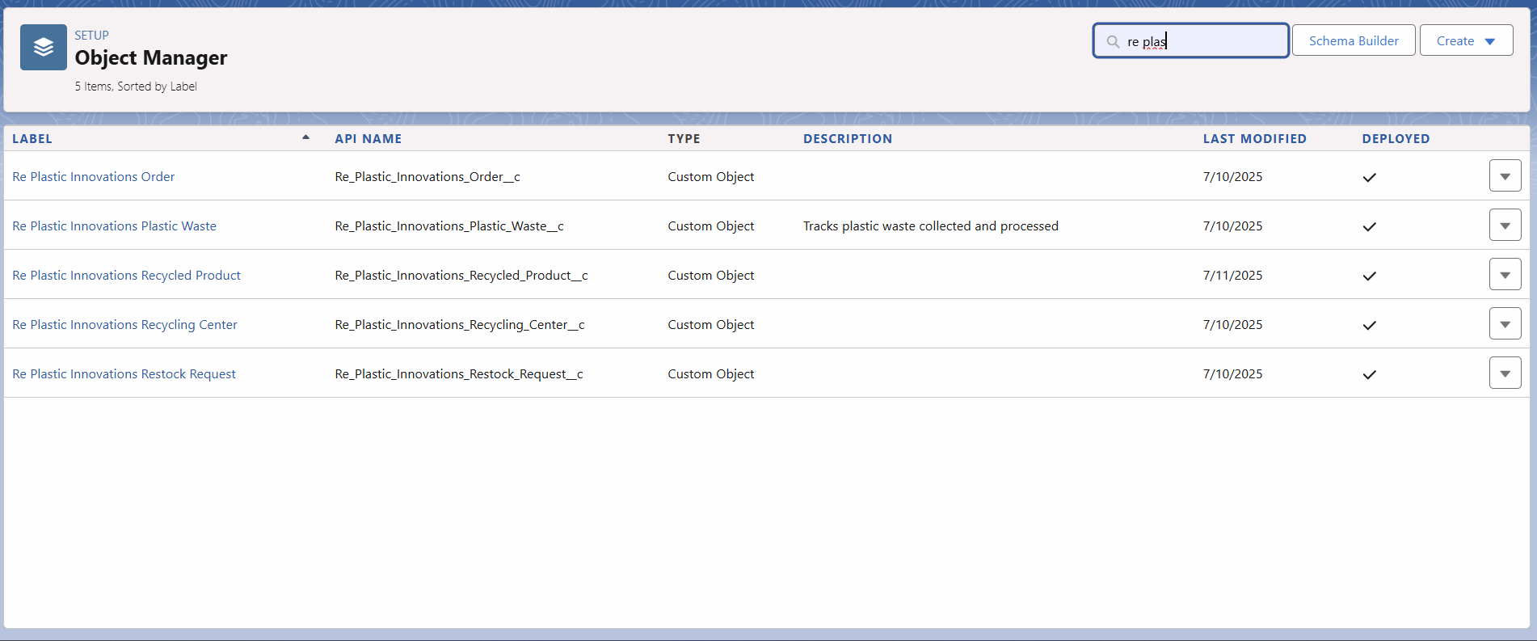**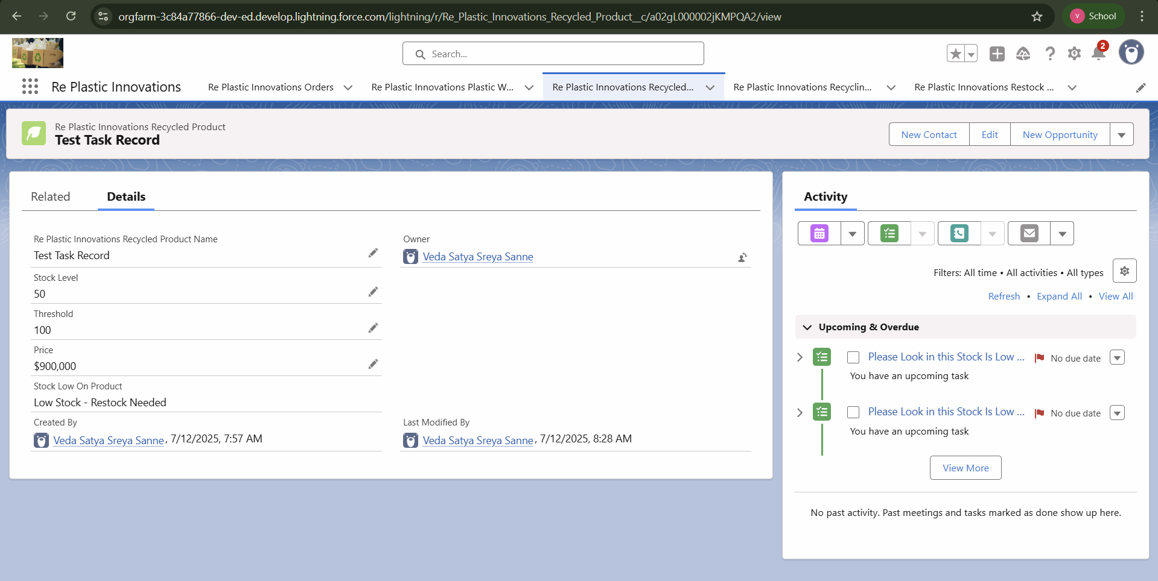 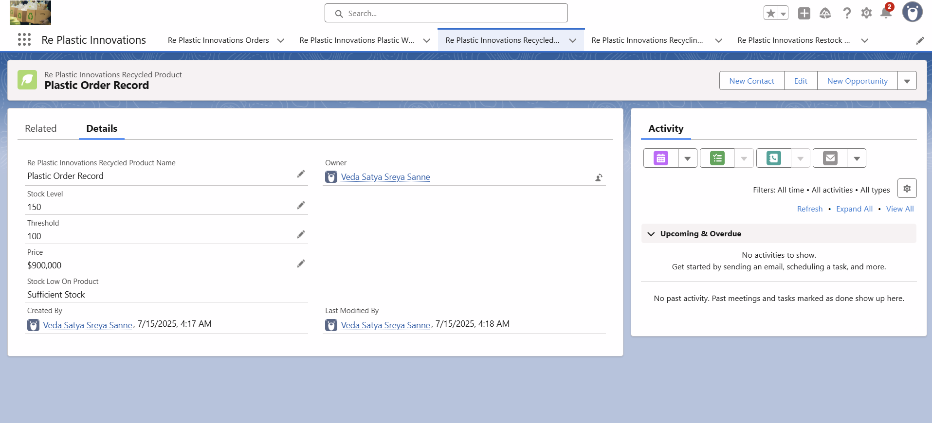 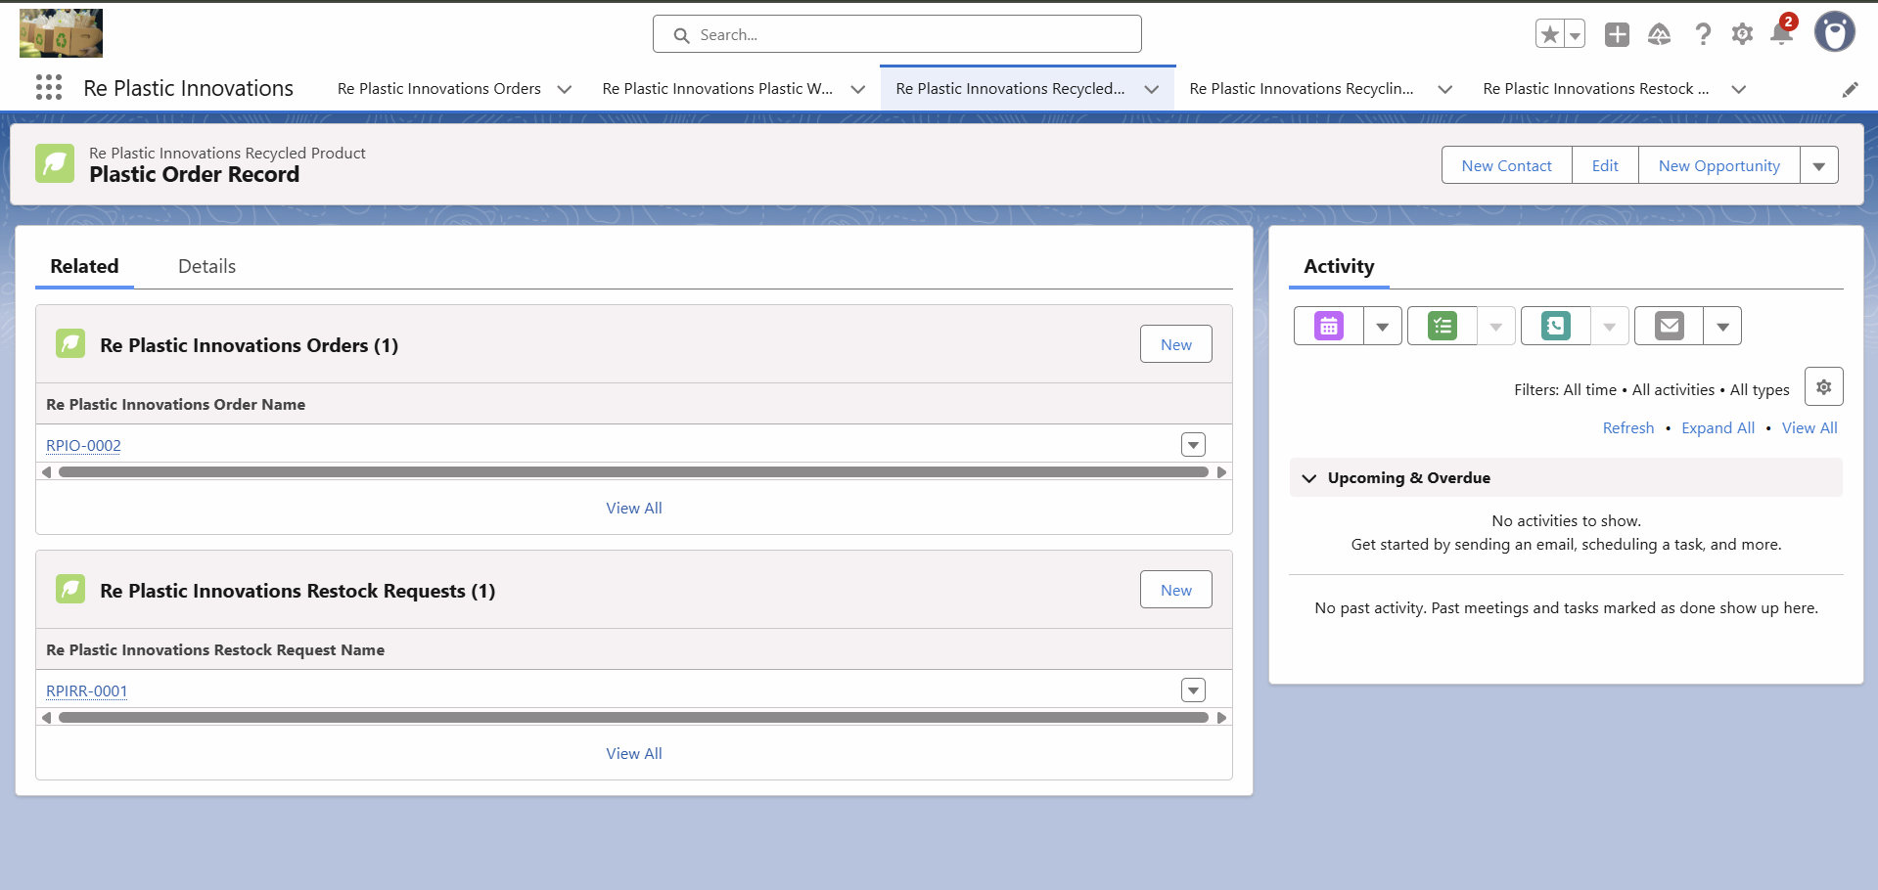

**Future Enhancements**

* AI Integration: Predictive alerts for low inventory based on usage trends
* Mobile Compatibility: Allow field collectors to update records via mobile
* Chatbot Support: Handle order and restock inquiries automatically
* ERP Integration: Connect with inventory or billing systems
* Approval Process: For restock and high-value orders